# Page refresh leads to file leak

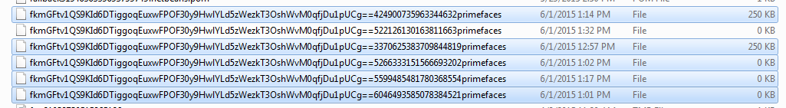

On this line the stored content for the uniqueId gest crushed on the refesh with a file with 0 bytes.

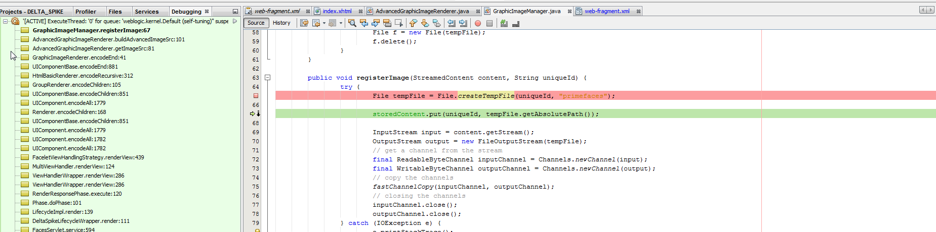

## Here we see that the new temp file absolute path corresponds to the file with 0 content:

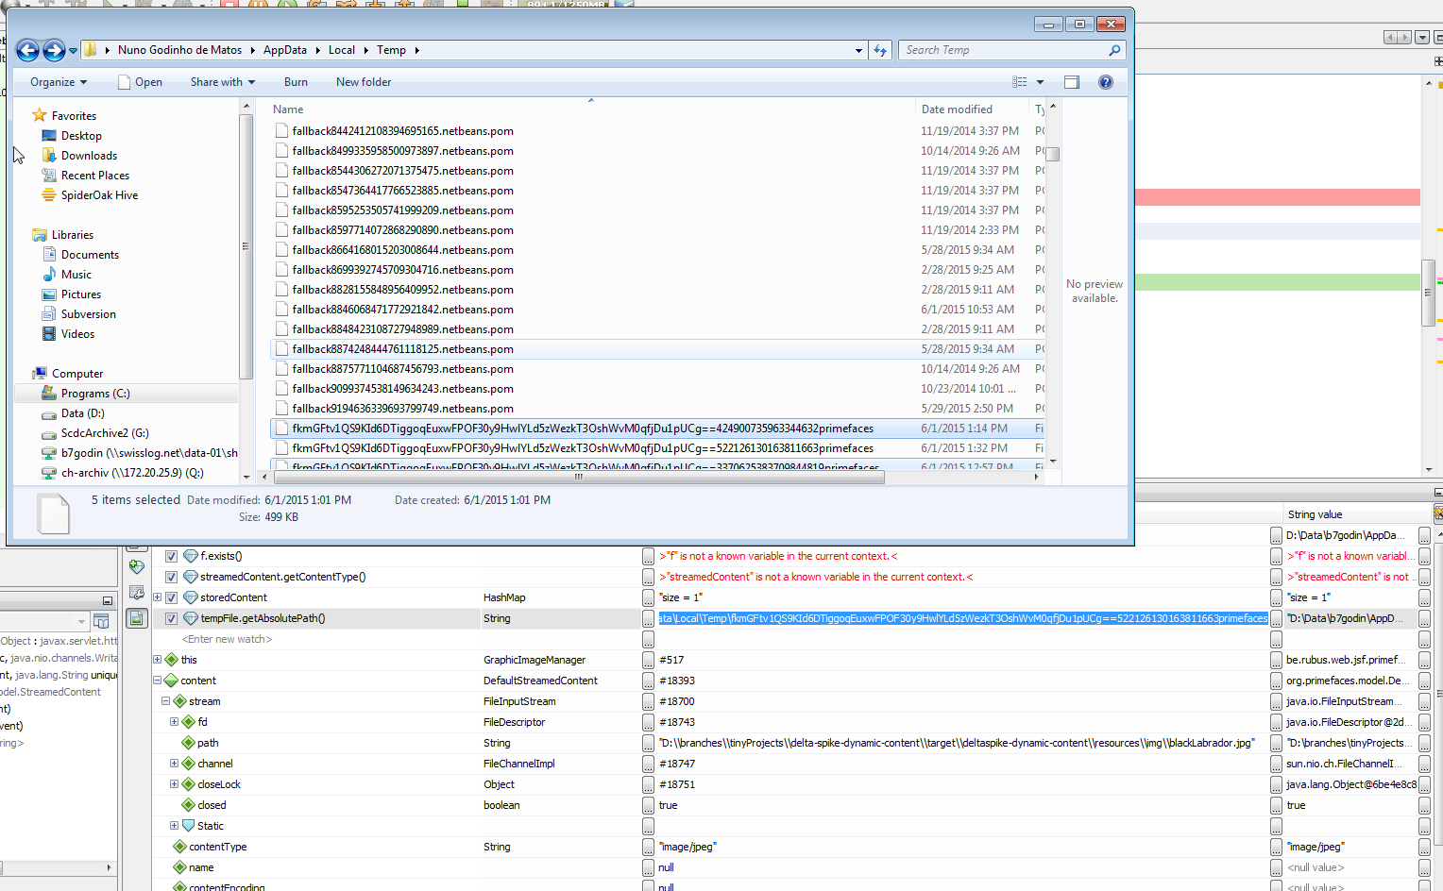

He should flush the input stream into the file.

## He closes the input and output streams



And therefore he cannot

## Another bug the closing of the input stream is not a good idea:

